**Chapter 1**

Introduction

* 1. **Overview**

An Office Management System is a crucial tool that helps streamline various functions within an office environment. These systems are designed to meet the daily requirements of office work, enhancing efficiency and organization. Key features and modules of office management systems include record management, task tracking, and collaboration tools.

Office management solutions are typically software programs aimed at assisting office managers in handling diverse responsibilities. These responsibilities may include resource management, communication facilitation, and workflow optimization. Such systems contribute to creating a productive workplace by automating routine tasks and providing a centralized platform for information and task management.

The development of an office management system project involves creating a web-based application tailored to manage various operations within an office setting. This can include functionalities such as document management, employee scheduling, and communication tools.

* 1. **Problem Statement**

Manual handling of employee information poses a number of challenges. This is evident in procedures such as leave management where an employee is required to fill in a form which may take several weeks or months to be approved. The use of paper work in handling some of these processes could lead to human error, papers may end up in the wrong hands and not forgetting the fact that this is time consuming. A number of current systems lack employee self-service meaning employees are not able to access and manage their personal information directly without having to go through the admin or their managers. Another challenge is that multi-national companies will have all the employee information stored at the headquarters of the company making it difficult to access the employee information from remote places when needed at short notice. The aforementioned problems can be tackled by designing and implementing a web-based Office Management System.

This system will maintain employee information in a database by fully privacy and authority access. The project is aimed at setting up employee information system about the status of the employee, the educational background and the work experience in order to help monitor the performance and achievements of the employee through a password protected system.

* 1. **Project Background**

Employees are the backbone of any company therefore their management plays a major role in deciding the success of an organization. Office Management System makes it easy for the employer to keep track of all records. This software allows the administrator to edit employees, add new employees as well as evaluate an employee’s performance. Employees can be managed efficiently without having to retype back their information in the database. You can check to see if there are duplicate positions/employees in the database.

* 1. **Objectives**

In this world of growing technologies everything has been computerized. With large number of works opportunities, the Human workforce has increased. Thus, there is a need of a system which can handle the data of such a large number of Employees. This project simplifies the task of maintaining records because of its user-friendly nature. The objective of this project is to provide a comprehensive approach towards the management of employee information. This will be done by designing and implementing an Office Management System that will bring up a major paradigm shift in the way that employee information is handled.

The objectives of this system include:

* Design of a web-based Office Management System fulfills the requirements such as project management, leave management, report generation to assist in performance.
* Well-designed database to store employee information.
* A user friendly front-end for the user to interact with the system.

**Chapter 2**

Literature Review

An OMS refers to the systems and processes at the intersection between human resource and information technology. It merges human resource as a discipline and in particular it’s basic human activities and processes with the information technology field whereas the programming of data processing systems evolved into standardized routines and packages of enterprise resource planning software.

An organization or company with a very large number of employees manages a greater volume of data. This activity can be daunting without a more sophisticated tool to store and retrieve data. The various levels of sophistication can be examined by looking at the evolutionary aspects of HR technology. These aspects can be characterized into four stages of development: Paper-based systems, early personal computer (PC) technology, electronic databases, and Web-based technology.

The benefits of automation are becoming widely known to HR and other areas of the business. The focus has shifted to automating as many transactions as possible to achieve effectiveness and efficiencies.

The technology of the future will be about speedy access to accurate current information, and reliability to access this information via multiple systems will give organizations a strategic edge. HR is expected to relinquish its role as sole owner of HR information, so that managers and employees can use this information to solve their own problems using Web-based systems. This new system will not necessarily mean reduction in staff. The new system will enable professionals to focus on transforming information into knowledge that can be used by the organization for decision making; it will be about HR and IT working together to leverage this technology. A recent study by the Hackett Group, a business process advisory firm found that high-performing organizations spend 25 percent less than their peers on HR because they use technology effectively.

The two most popular Web-based Office Management System applications used today are self-service for employees and self-service for managers. These applications have enabled companies to shift responsibility for viewing and updating records onto individual employees and have fundamentally changed the manner in which employees acquire information and relate to their departments.

**Chapter 3**

Proposed System

**3.1. Problem Formulation**

The problem formulation for the office management system revolves around several key aspects. Firstly, the traditional office management faces challenges in terms of efficiency and resource utilization. The problem lies in finding an optimal way to automate and improve project management using web technologies and the chosen stack of PHP, MySQL, HTML, AJAX, and the Apache server. This involves developing a system that streamlines the employee management, project management and other office works that enhances the overall productivity of an organization.

Secondly, effective, and secure communication between employees and officials makes everything easy for an organization. Thus, the problem is to incorporate secure communication within the office, ensuring real-time interaction while an ongoing project. This requires implementing features that facilitate seamless communication, enabling employees to share their issue related to project, ask questions, and receive timely guidance from the higher authorities.

Thirdly, creating a user-friendly interface is crucial to enhance the user experience for both employees and officials. The problem is to design an intuitive and visually appealing interface using HTML and Tailwind CSS that caters the different devices. This involves considering aspects such as responsiveness, ease to navigate, and intuitive interaction.

Lastly, ensuring secure data management is paramount to protect employee’s information. The problem lies in implementing robust data management practices using PHP, MySQL, and a secure database. This includes proper storage, retrieval, and protection of information, maintaining data integrity, privacy, and confidentiality throughout the system.

**3.2. Proposed Methodology**

The proposed methodology for developing the office management involves the following steps. Firstly, a thorough analysis of the requirements and functionalities of the system will be conducted. This includes the essential features such as create, edit and delete staff, project management, performance tracking, and many more things.

Next, the system architecture will be designed, outlining the overall structure and flow of the application. This will involve defining the different components, modules, and their interactions. The chosen technologies, PHP, MySQL, HTML, Tailwind CSS, and the Apache server, will be integrated to provide a robust and scalable foundation for the system.

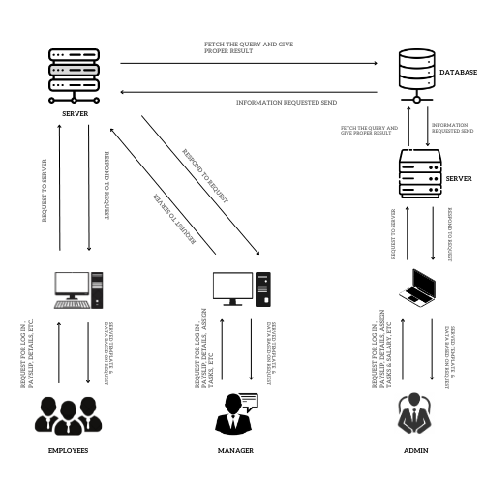

**Fig:3.1: Proposed System**

The development phase will involve coding the different modules of the system. PHP will be used for server-side scripting, while HTML and Tailwind CSS will be employed for designing the user interface. The XAMPP server will be utilized for local development and testing purposes, ensuring a smooth development process.

The database schema will be designed and implemented using MySQL to ensure efficient data storage and retrieval. Proper normalization and security measures will be incorporated to maintain data integrity and protect employee’s information.

During the implementation phase, thorough testing and debugging will be carried out to identify and fix any issues or bugs. User feedback and usability testing will be conducted to refine the user interface and improve the overall user experience.

Finally, the system will be deployed on a suitable web hosting platform, ensuring its availability for users. Ongoing maintenance and updates will be performed to address any system enhancements or security updates.

Overall, the proposed methodology encompasses requirements analysis, system design, development using PHP, HTML, Tailwind CSS, AJAX and the XAMPP server, database implementation using MySQL, testing, deployment, and maintenance. By following this methodology, the office management system will be developed with robust functionality, user-friendly interface, and secure data management capabilities.

**3.3. Unique Features**

The office management system offers several unique features that distinguish it from traditional office systems. Firstly, the system provides a convenient and accessible platform for employees to higher officials, eliminating the need physical interaction. This feature helps both the employee and the officials to do their work conveniently.

Secondly, the system incorporates secure communication channels between the employee and higher officials. This feature enables employees to securely communicate with their managers and admin, ask questions, and report any issue through the platform. It promotes efficient and effective communication, allowing employees to receive timely responses and guidance from their manager or other higher officials.

Additionally, the system incorporates a user-friendly and intuitive interface. The use of HTML and Tailwind CSS allows for responsive and visually appealing designs, ensuring seamless navigation across different devices. This feature enhances the overall user experience for both employee and the organization.

Moreover, the system ensures secure data management practices. Employees information, including personal and educational details, is securely stored and protected within the system's database. Robust security measures are implemented to maintain data integrity and confidentiality, complying with privacy regulations and standards.

**Chapter 4**

Requirement Analysis and System Specification

**4.1. Feasibility study (Technical, Economical, Operational)**

The feasibility study for the office management system, utilizing PHP, MySQL, HTML, Tailwind CSS, and the Apache server, assesses its technical, economical, and operational aspects.

From a technical perspective, the chosen technologies demonstrate feasibility. PHP and MySQL provide a robust and widely adopted combination for server-side scripting and database management, ensuring efficient data processing and storage. HTML and Tailwind CSS enable the development of a responsive and user-friendly interface that can be accessed across various devices. Apache server facilitates local development, testing, and deployment, ensuring technical compatibility and scalability.

In terms of economic feasibility, the utilization of open-source technologies like PHP, MySQL, HTML, and Tailwind CSS contributes to cost-effectiveness by eliminating the need for expensive licenses. Apache, being a free and comprehensive web server solution, further supports the project's economic feasibility. However, considerations should be made for hosting and maintenance costs, as well as potential expenses related to security measures and regular updates.

Regarding operational feasibility, the office management system offers practicality and efficiency. It enhances the system by automating scheduling tasks, project uploading process and improving resource utilization. The system streamlines communication between employees and higher officials, allowing for real-time. The user-friendly interface enables ease of use for both employees and organization.

**4.2. SDLC model to be used**

The Iterative Model would be a suitable SDLC model for developing the office management system. The Iterative Model involves the development of the system through repeated cycles or iterations, with each iteration delivering a working increment of the software. Here's how the Iterative Model would apply to the development of the office management system:

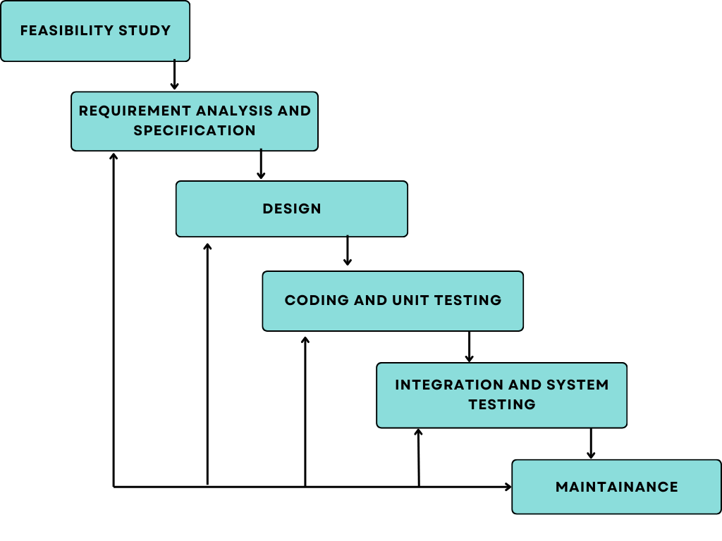

**Fig: 4.1: Iterative Model**

**4.2.1. Requirements Gathering:** In the initial iteration, the project team would gather the requirements for the system, including dashboard section, project section, individual performance section, and salary pay slip generation section.

**4.2.2. Design and Development:** The team would design and develop a functional increment of the system, focusing on key features identified in the requirements gathering phase. This includes designing the user interface using HTML and Tailwind CSS, implementing logic using PHP, and integrating MySQL for data storage.

**4.2.3. Testing and Feedback:** After completing each iteration, the developed increment would undergo thorough testing to identify any defects or issues. Feedback from users and stakeholders would be collected to assess the system's functionality and usability.

**4.2.4. Iteration Refinement:** Based on the feedback received, subsequent iterations would refine and improve the system. This could involve adding new features, enhancing existing functionalities, and addressing any reported issues or bugs.

**4.2.5. Repeat Iterations:** The development process would continue with multiple iterations, each adding new increments and improving the system's overall functionality and usability. The number of iterations would depend on the project scope, timeline, and feedback received.

The Iterative Model allows for flexibility and adaptability as it enables early delivery of working increments and incorporates feedback from users throughout the development process. This is particularly beneficial for projects like the office management system, where requirements may evolve, and user satisfaction is crucial.

**4.3. Functional Requirements:**

**Authentication**

* **Login:** The user can login to the Office Management system with his/her email and password.
* **Logout:** The user can log out from the Office Management System.

**Login failure:** If the user does not exist in the database or the user has not yet being authorized by the Office Management System admin.

**Authorization**

* **User role check:** After logging in, the user role will be checked from the database and the user interface will be displayed according to their role.

**Process Data**

* **Display:** User with defined roles can display the content of the database. Being more specific, employee can only view his/her personal information. Manager can not only see his/her personal information but also employee’s information who are under his/her department. Admin can display their personal information and all employees’ information.
* **Edit:** A user with employee role can edit his/her specific personal information. Manager can only edit employees’ personal information that is under his/her coverage except user role type. Admin can edit all information related to all employees’ including their user role type.
* **Search:** User with Manager role can search the content of database for the employees’ who are under his/her coverage. Admin roles can search all the employees’ information in the database. Search feature works on specific keywords showing employee’s characteristics, peculiarities, skills, features, and etc.
* **Update authentication:** This feature can be used only by admin role type. Admin can update the role type of a specific user.

**Leave Application/Approval**

* **Leave application:** The user can be able to fill in leave application form in the appropriate fields.
* **Leave approval:** The admin can be able to approve leave applications based on the reasons stated, length of leave.
* **Leave days accrued:** The user shall be able to check the number of leave days accrued.

**Recruitment**

* **Add new employee:** Admin role type is able to add a new employee to the database. The new employee will have all the required basic personal information related to him/her. The new created employee will have an id given by system. After generating the EMP ID, the admin will set role and department for him/her.

**Project Management**

* **Create project:** The Admin will be able to create a project for the departments.
* **Work Breakdown Structure:** The manager of that department to whom the project is assigned will be able to assign tasks to the project team as well as monitor their progress.

**Chapter 5**

System Design

**5.1. System Architecture**

The architecture is structured for organizations or businesses. Client-server architecture was used and we used thin client-server. The office management system has two components namely: the server-side and client-side that run on the browser. In the client approach almost all the processing work was done on demand at the server end and the client task was to display data and information on the screen. While in thin client-server architecture, the web browser is the client. This architecture was used because with it users will not be required to install any software on their PCs expect a standard web browser, which often come, with most PC operating system. Clients would also not require any powerful PC; users can use any PC with a web browser such as laptop/notebook and desktop PC. The servers would require higher configuration (in terms of hardware) because it would be regularly subjected to heavy load.

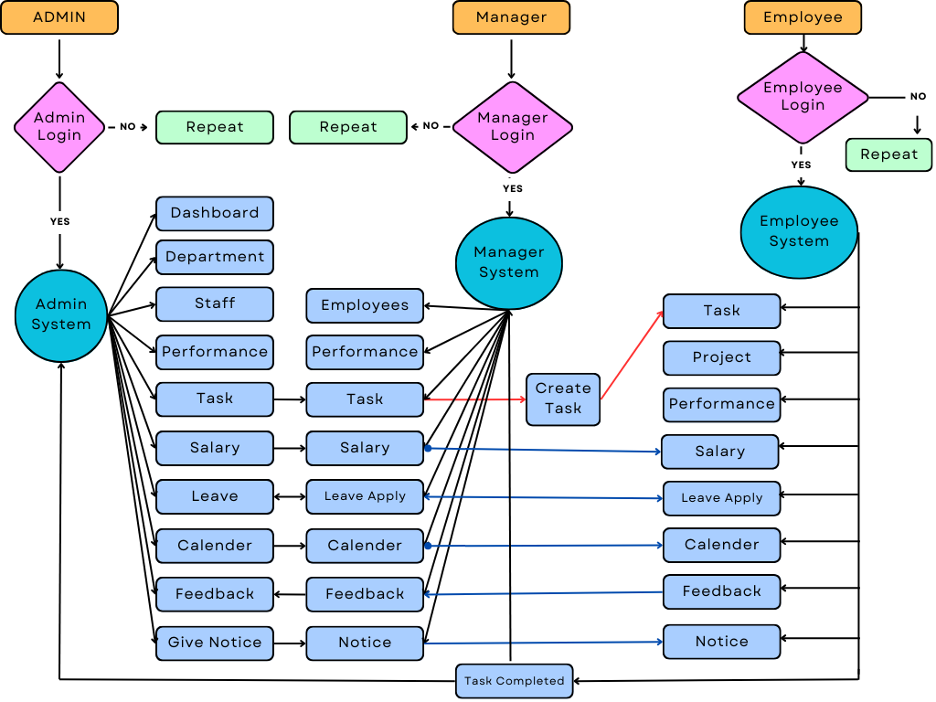

**Fig: 5.1: System Architecture**

**5.2. Admin Portal**

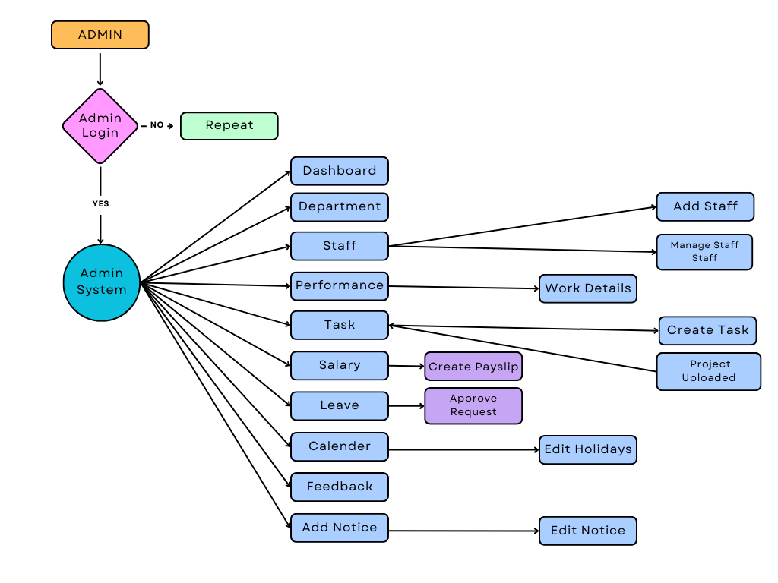

**Fig: 5.2. Admin Portal Dataflow Diagram**

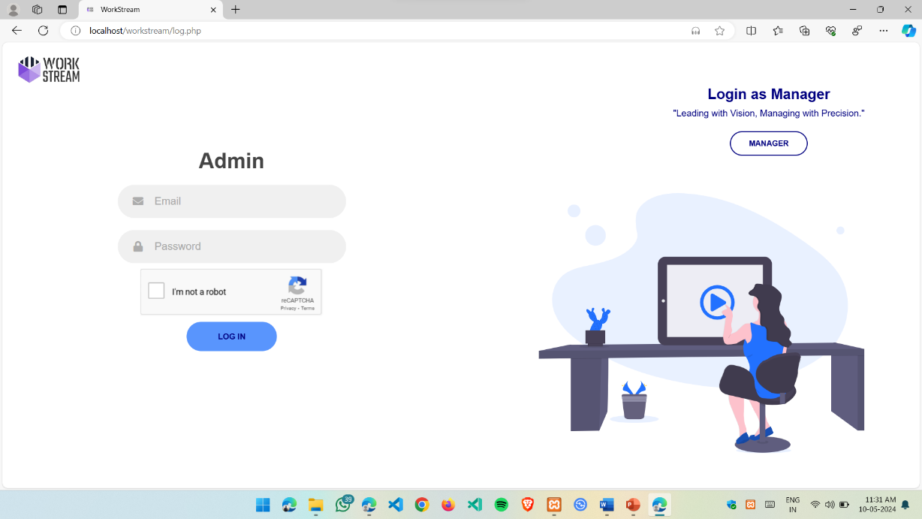

**Fig: 5.3. Admin Login Page**

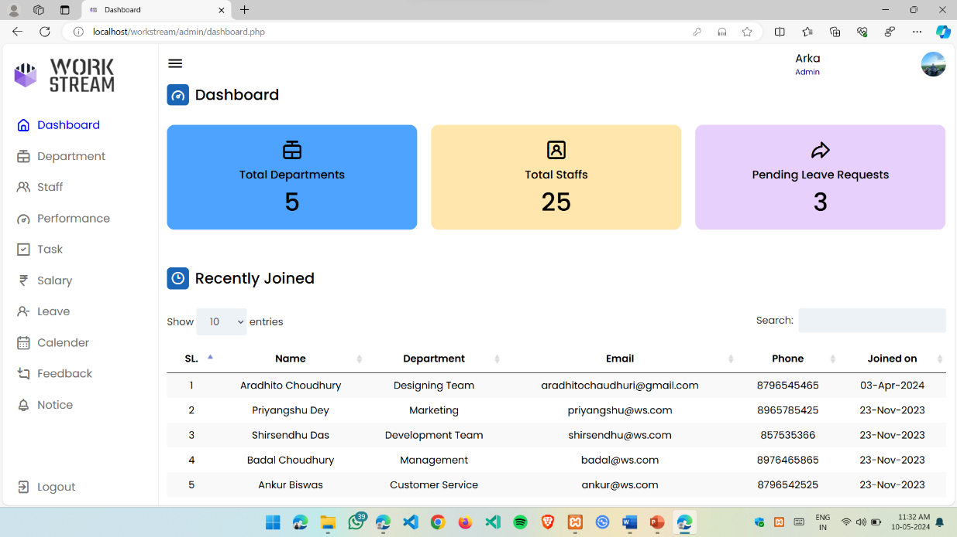**5.3. Admin Portal Login**

**Fig: 5.4. Admin Dashboard**

* **Dashboard:** After the admin has successfully login to the admin portal, first he comes to the Dashboard Section, in this section he can see total number of departments, staffs and pending leave requests and also recently joined employees.

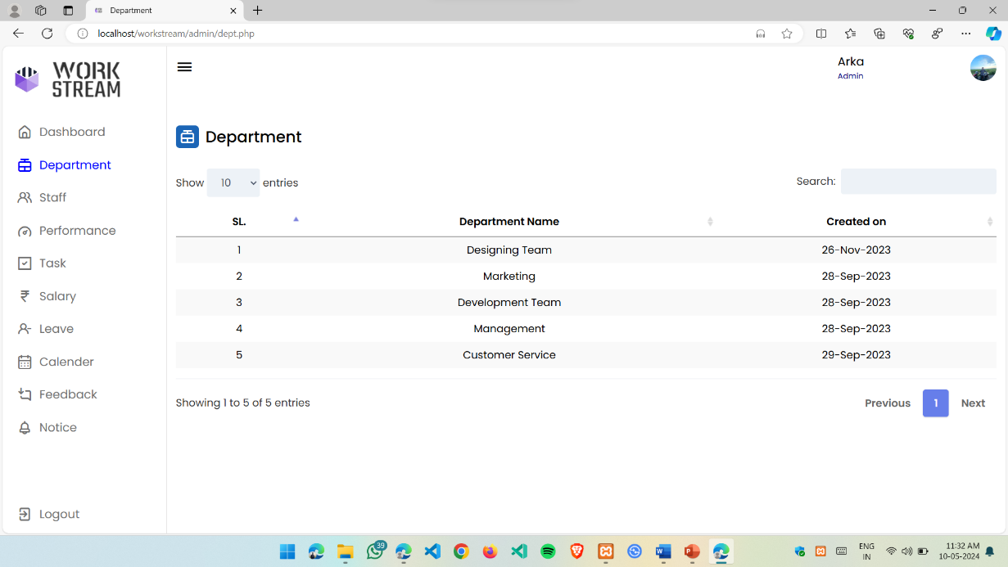

**Fig: 5.5. Department Page**

* **Department:** In this section the admin can see total number of departments present in their organization and their details.

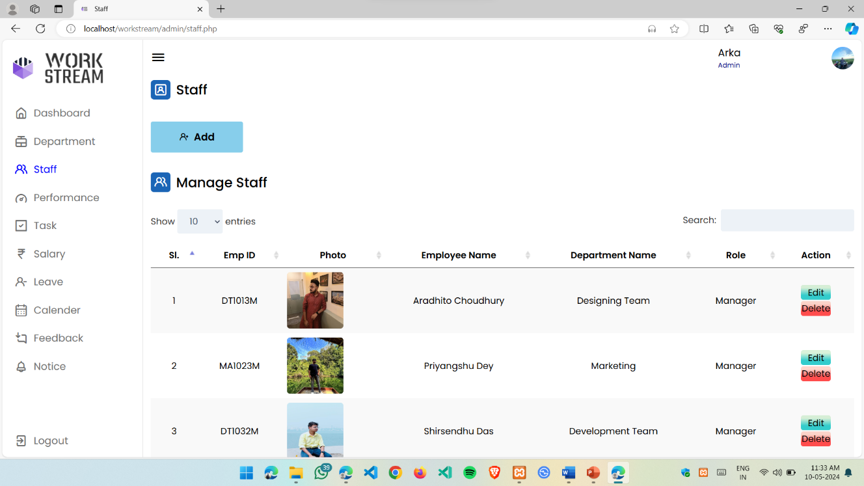

**Fig: 5.6. Staff** **Page**

* **Staff:** In this section admin can add, edit and manage the employees. He can

set their role and depertment from here.

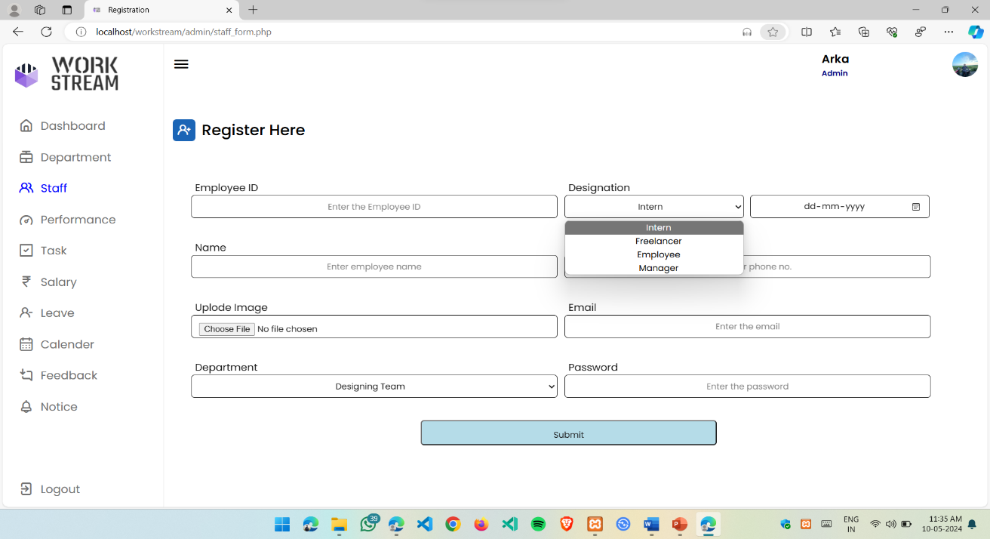

**Fig: 5.7. Staff** **Add Section**

* **Staff Add Section:** Here the admin can add new staffs which is either temporary or permanent. If the designation is selected to ‘Intern’ of ‘Freelancer’, the account will be deleted after the selected time.

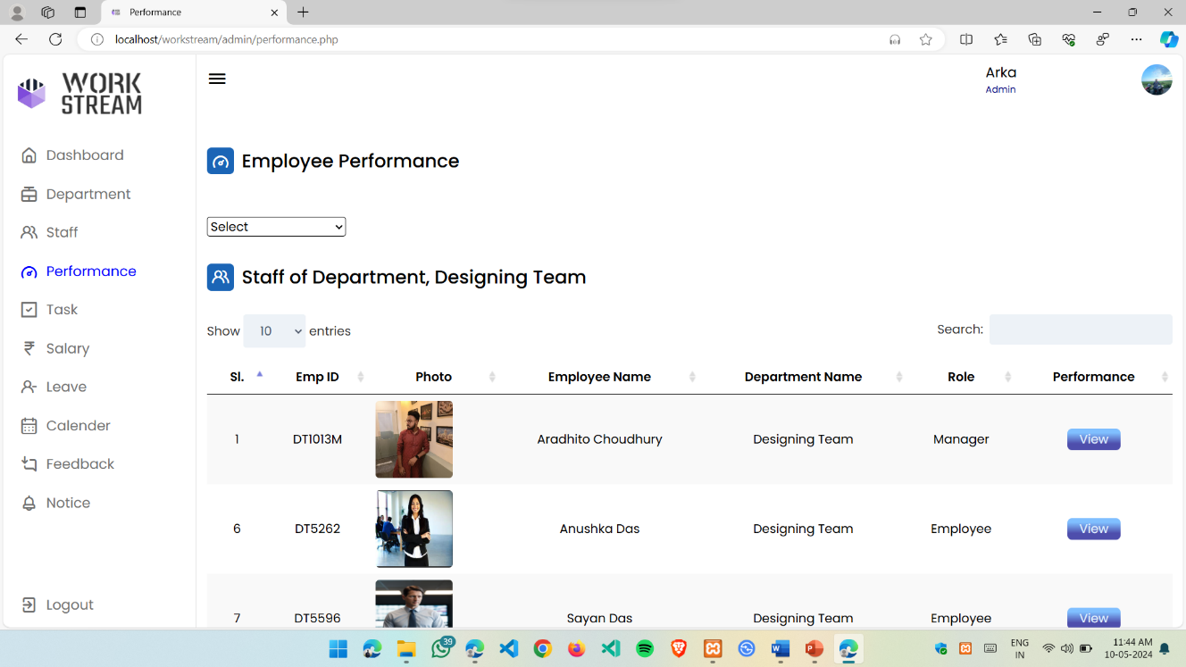

**Fig: 5.8. Performance Page**

* **Performance:** In this page admin can observe the overall performance of an individual employee depending on their work and its shown in an graphical form.

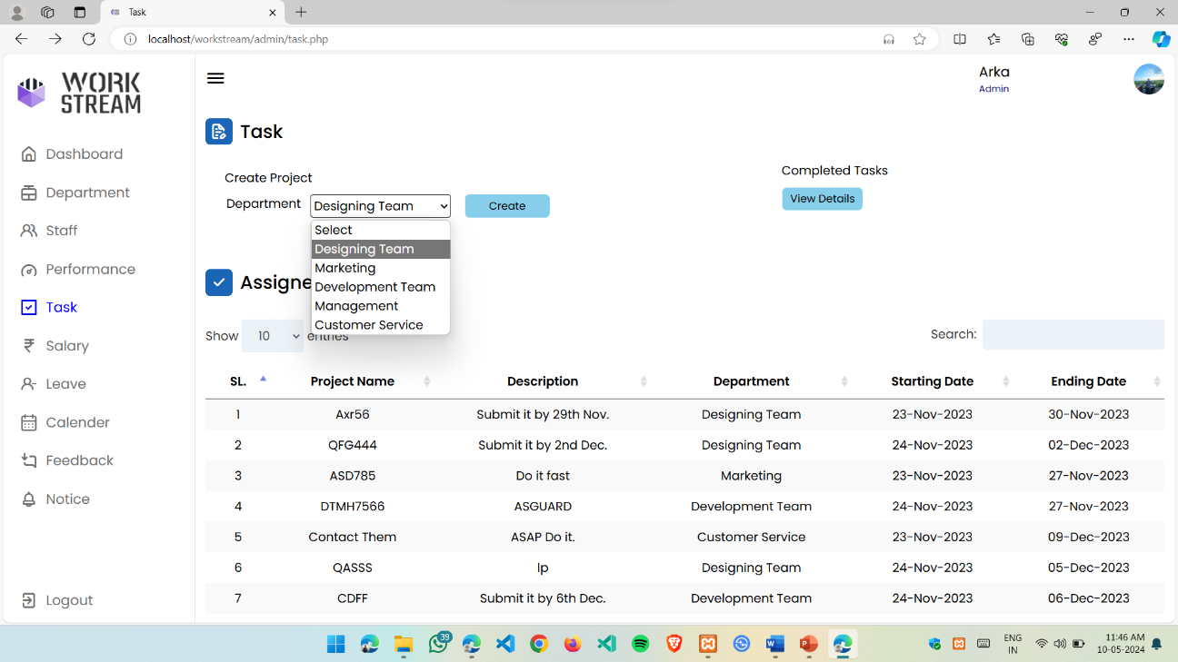

**Fig: 5.9. Task Page**

* **Task:** In this portion, admin can assign task to the departments, can see previous task assigned to the departments with the project name, description and the starting and ending date. Here he can also observe and download the project files which are already completed and uploaded by the departments.

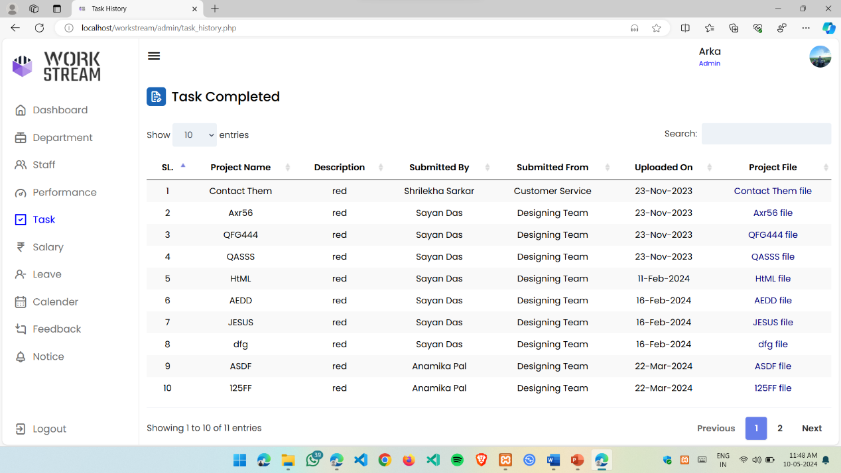

**Fig: 5.10. Task Completed**

* **Task Completed:** Here the admin can see and download the completed task which are uploaded by the employees.

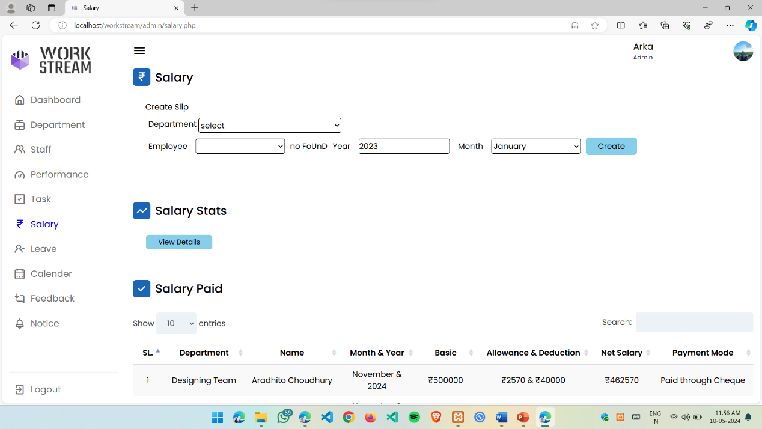

**Fig: 5.11. Salary Section**

* **Salary:** In this section admin can generate the salary pay slip for their managers and employees according to their department and can observe the pervious pay slip generated by him and also the issue date and also the salary stats.

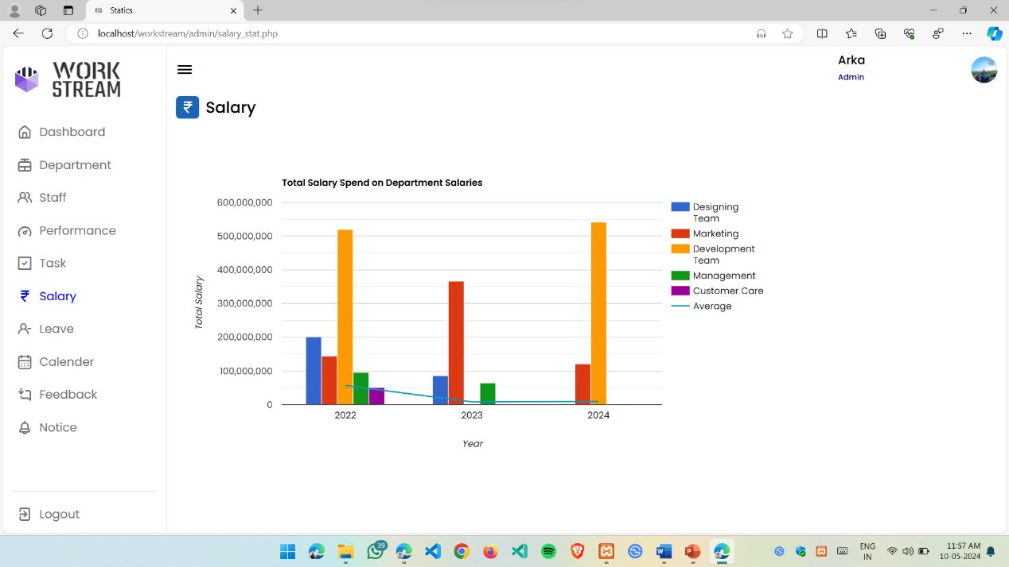

**Fig: 5.12. Salary Stats**

* **Salary Stats:** Here the admin can see the over all salary paid to the departments according to the year and can see the average.

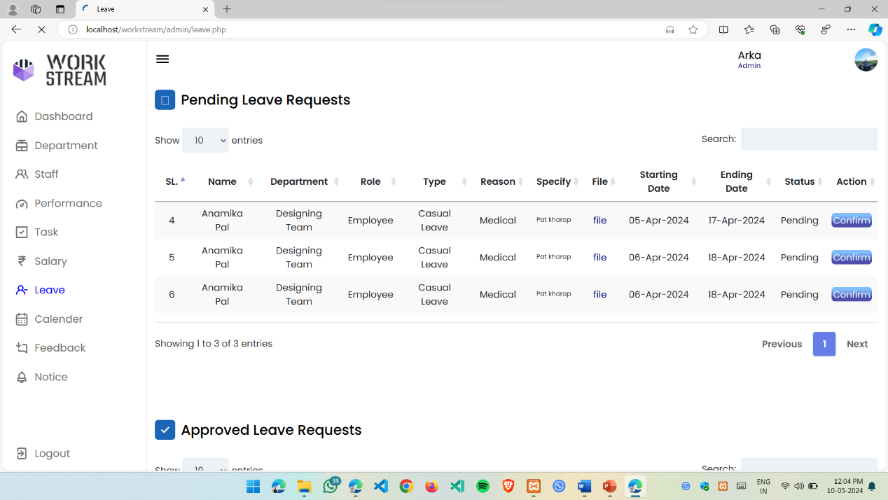

**Fig: 5.13. Leave Requests**

* **Leave Requests:** Here admin can observe all the leave requests send by the managers and the employees. He can accept it or reject it depending on the reason and the leave duration.

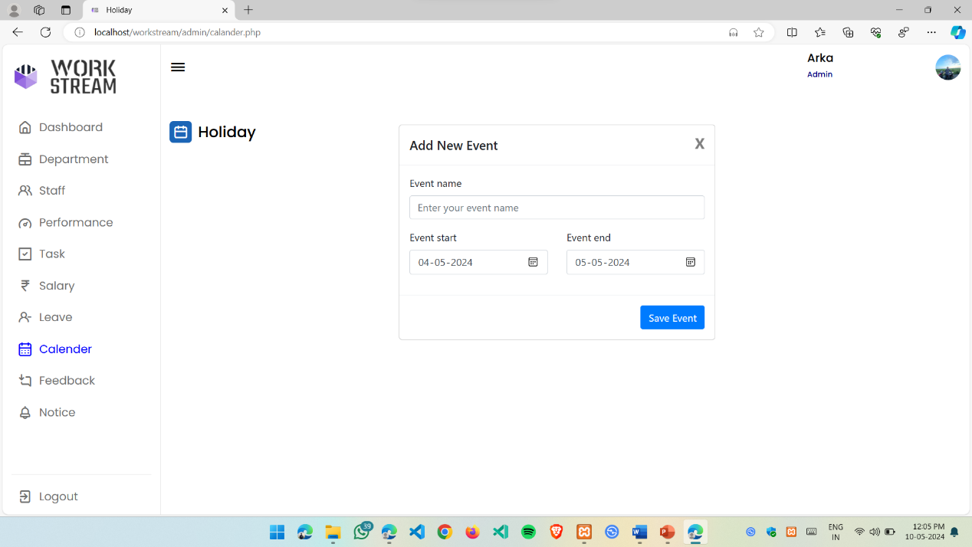

**Fig: 5.14. Calendar**

* **Calendar:** In this section admin can set holidays, meetings, and upcoming events for their employees and the managers.

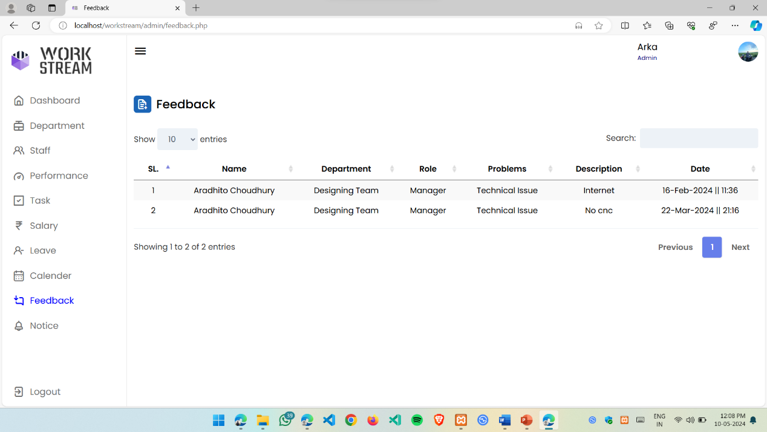

**Fig: 5.15. Feedback**

* **Feedback:** In this section admin can observe all the feedbacks given by the employees and the managers regards of anything.

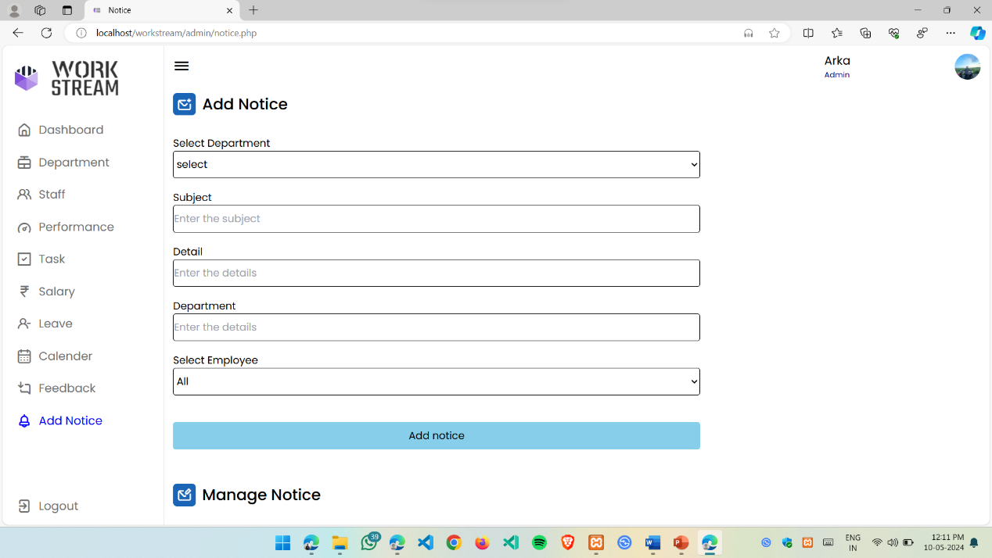

**Fig: 5.16. Add Notice**

* **Add Notice:** Here in this section admin can add, edit and manage the notices which are already send to the employee or manager individually or in a group.

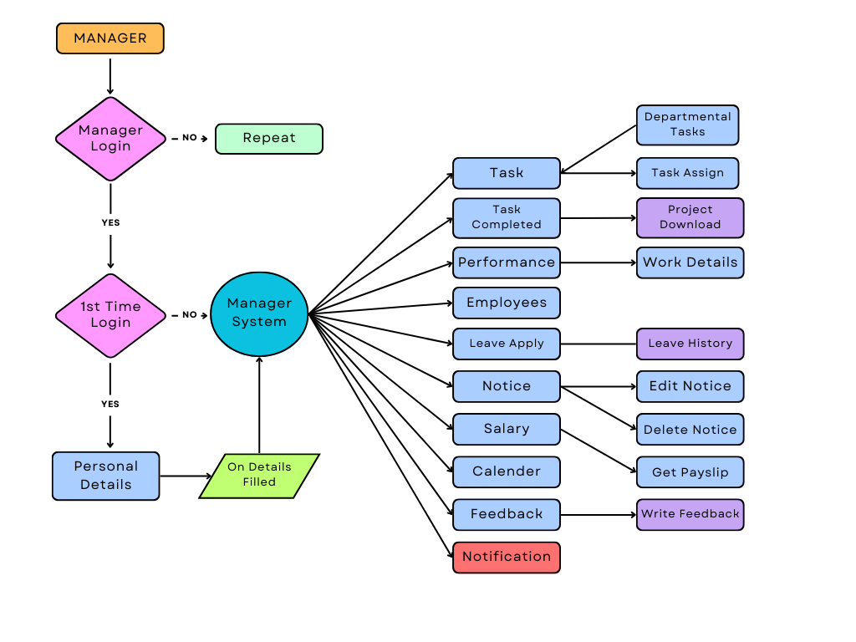**5.3. Manger Portal**

**Fig: 5.17. Manager Portal Dataflow Diagram**

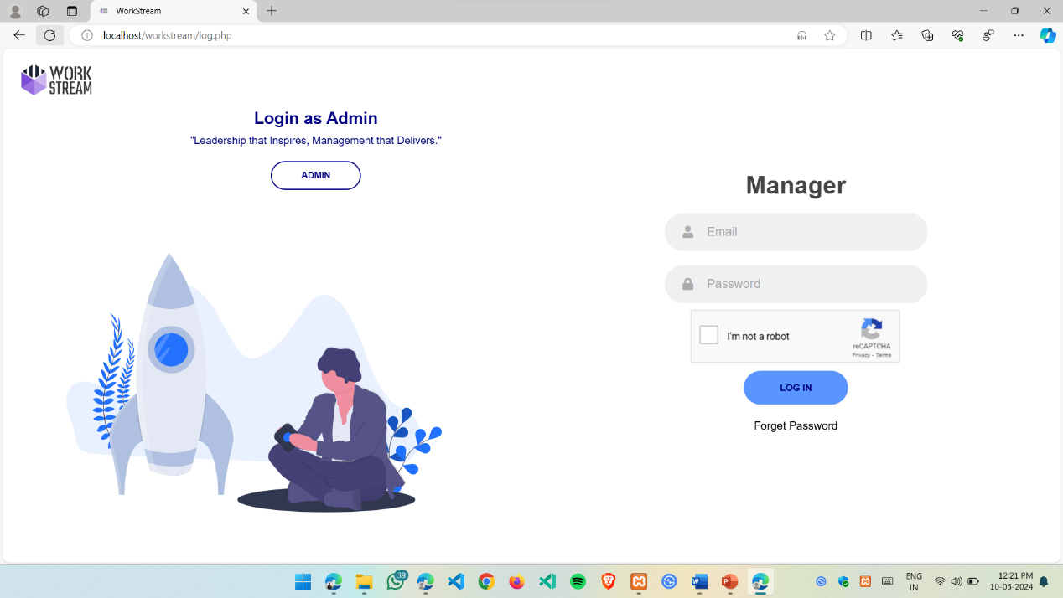

**Fig: 5.18. Manager Login Page**

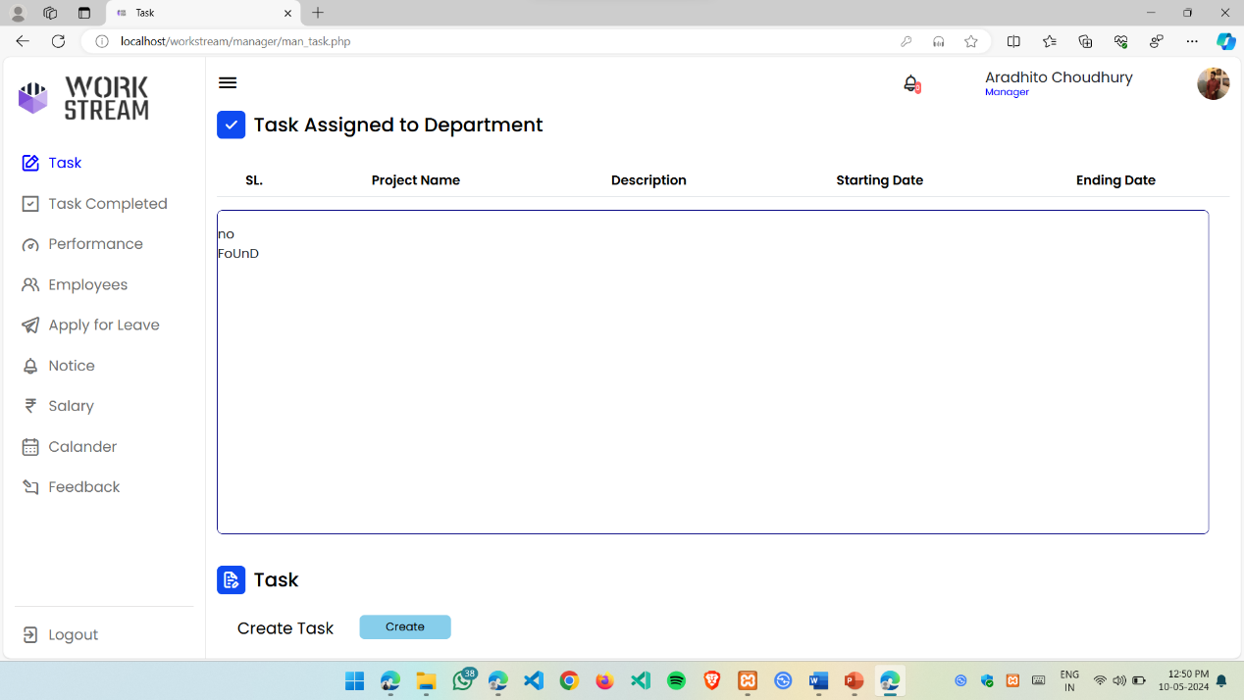

**Fig: 5.19. Manager Task Section**

* **Task section:** In this section manager see all the task and projects given to the department by admin. And the manager can also reassign the task to the employees of that department.

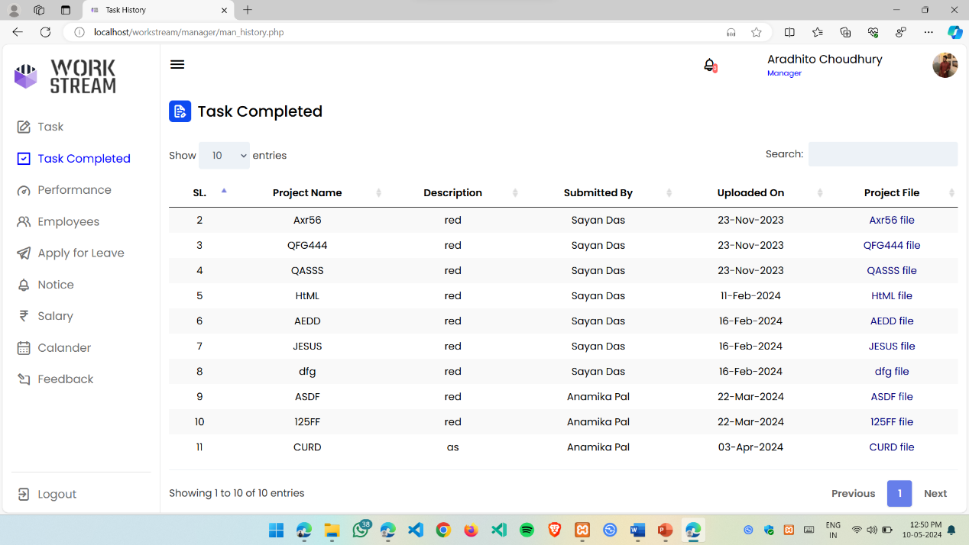

**Fig: 5.20. Task Completed**

* **Task Completed:** In this section the admin can see and download the project file which are completed and uploaded by the employees of that department.

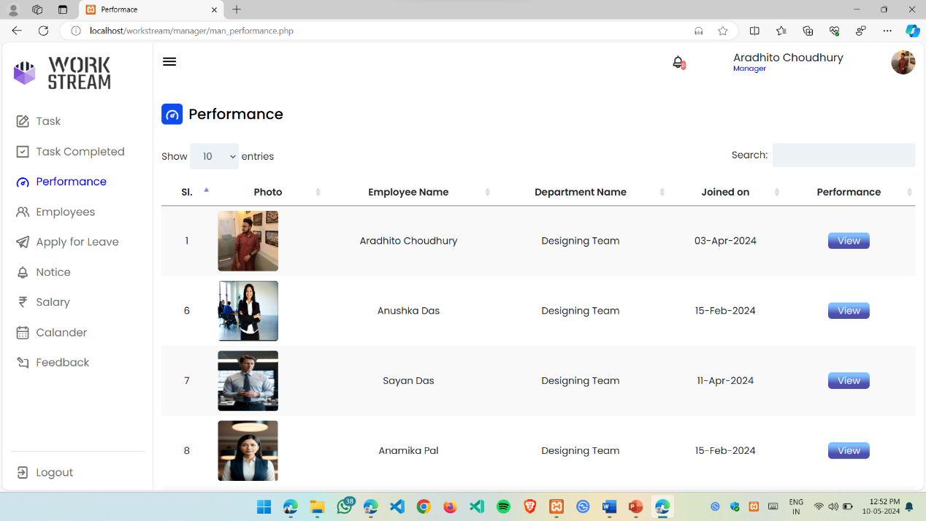

**Fig: 5.21. Performance**

* **Performance:** In this section manger can observe the performance of all the employees of that department according to their work in a graphical form.

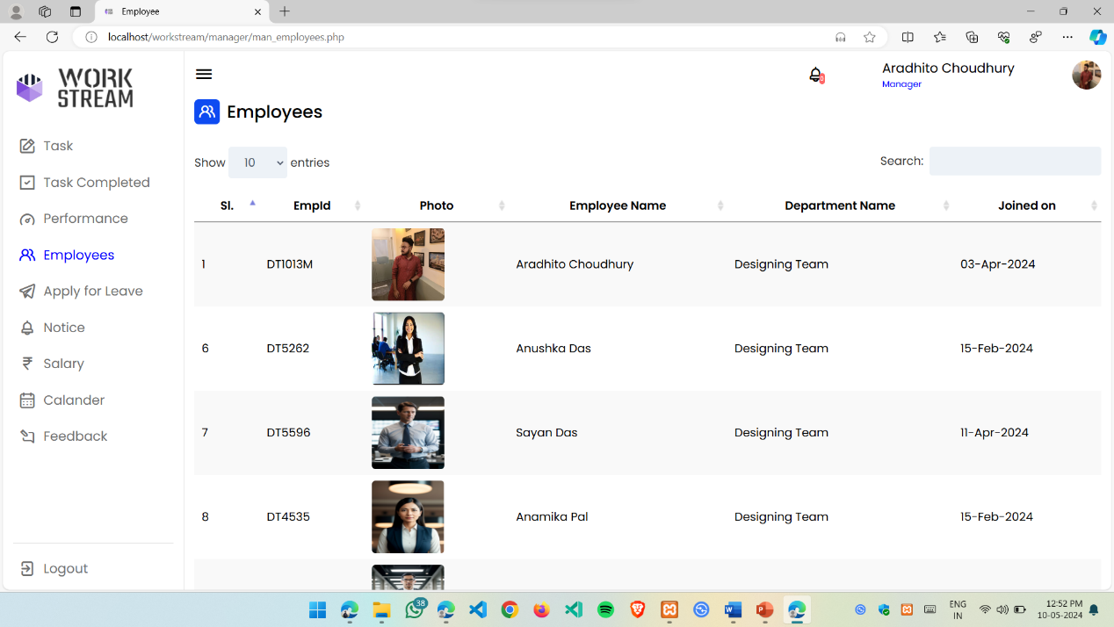

**Fig: 5.22. Employees**

* **Employees:** In this section manager can see all the personal and job role of the employees of that department.

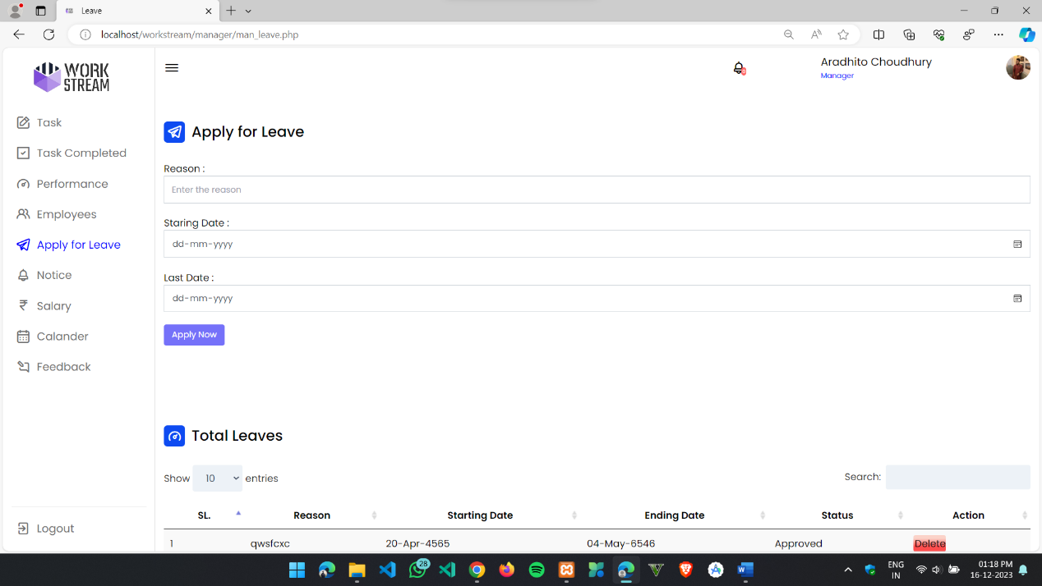

**Fig: 5.23. Apply for leave**

* **Apply for leave:**  In this section manager can apply for leave to the admin, here he can give the reason for leave and the starting and the ending date. He can also see the previous leave requests.

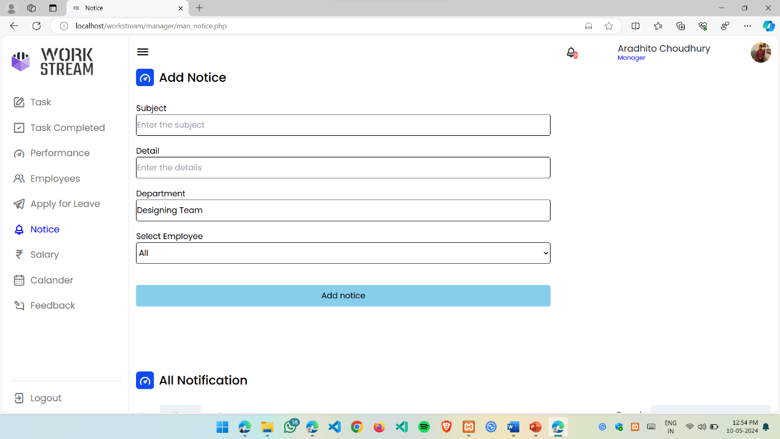

**Fig: 5.24. Add Notice**

* **Add Notice:** In this section the manager can add, edit and modify the notices which he has given to his employees.

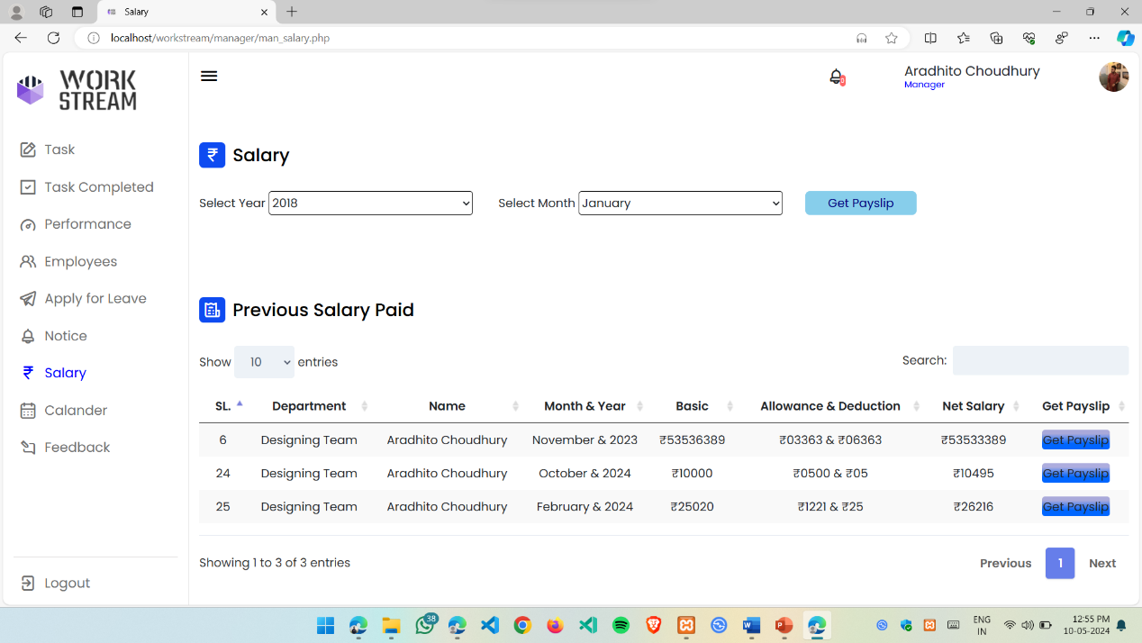

**Fig: 5.25. Salary**

* **Salary:**  In this section the manager can download the salary pay slip of last three months from the previous salary paid and from the upper part, by giving the year and month he can download the previous ones.

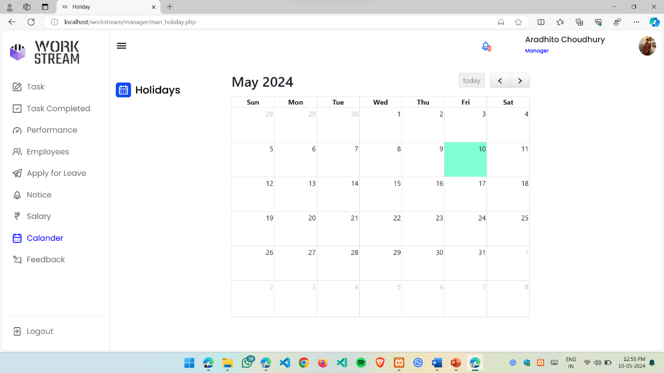

**Fig: 5.26. Calendar**

* **Calendar:** In this section manager can see all the holidays, meetings and upcoming events set by the admin.

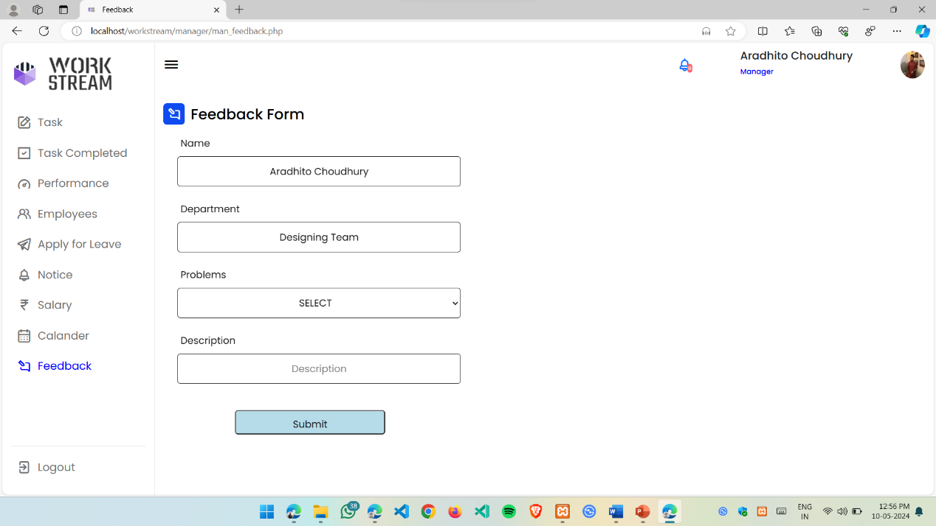

**Fig: 5.27. Feedback form**

* **Feedback form:** In this form manager can give feedbacks to the admin regards of anything such as any issue related to project or anything else.

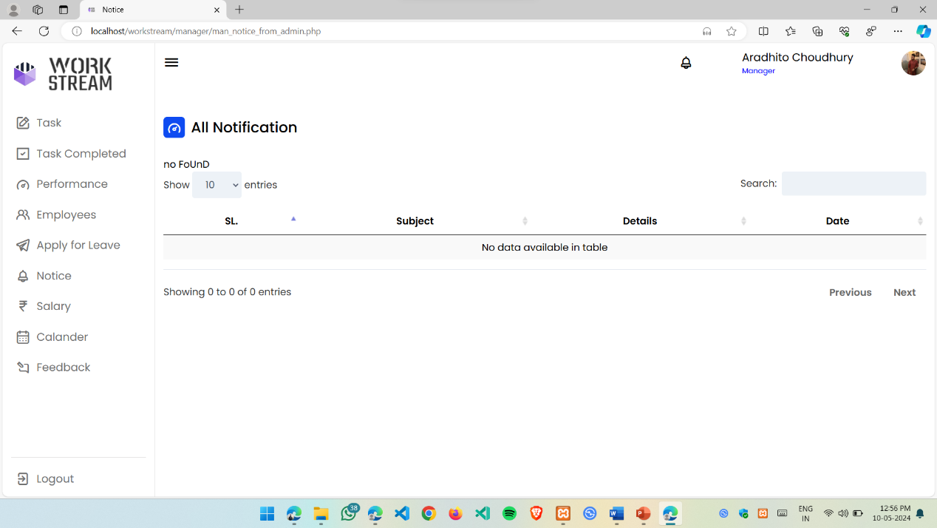

**Fig: 5.28. Notifications**

* **Notifications:**  In this section manager can see all the notifications given to him or the department by the admin.

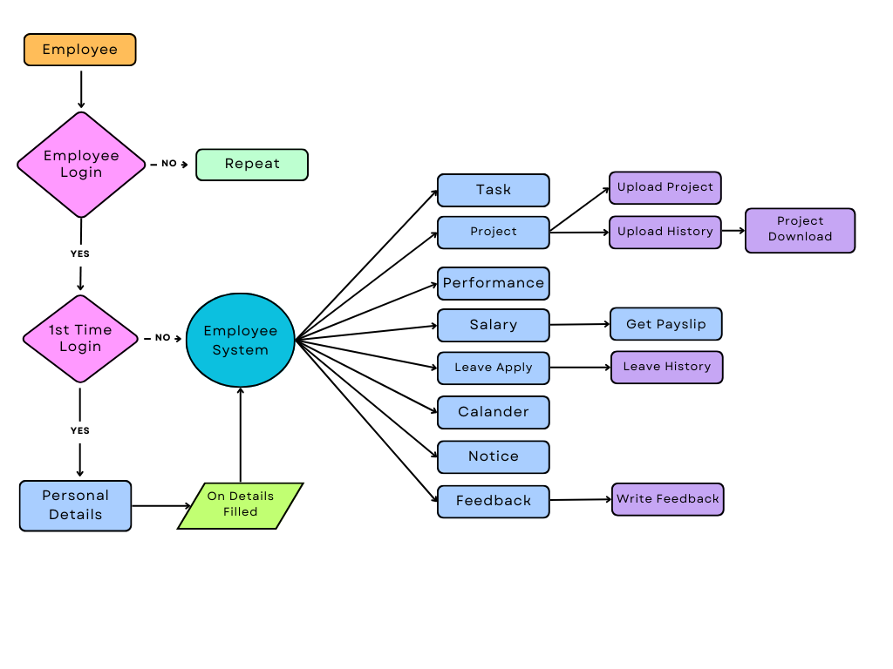**5.4. Employee Portal**

**Fig: 5.29. Employee Portal Dataflow Diagram**

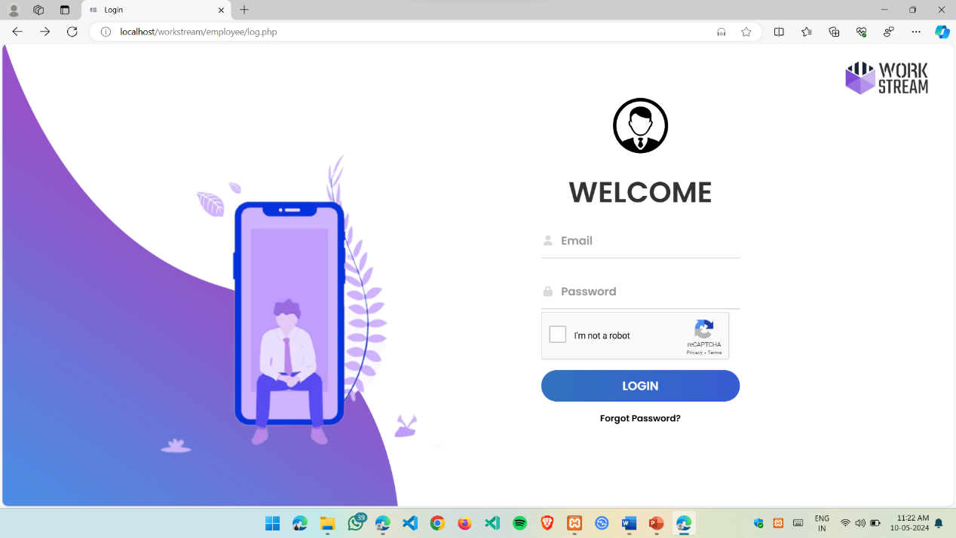

**Fig: 5.30. Employee Login Page**

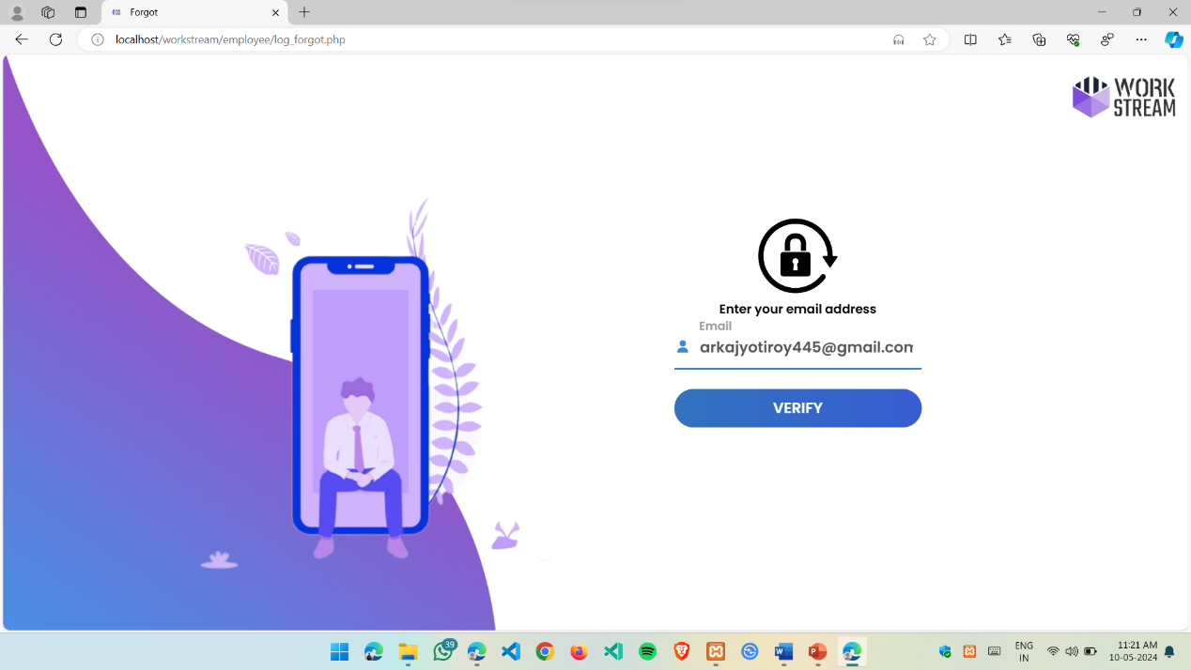

**Fig: 5.31. Forgot Password Section**

* **Forgot Password:** Here the employees can change their account password by entering the registered email address

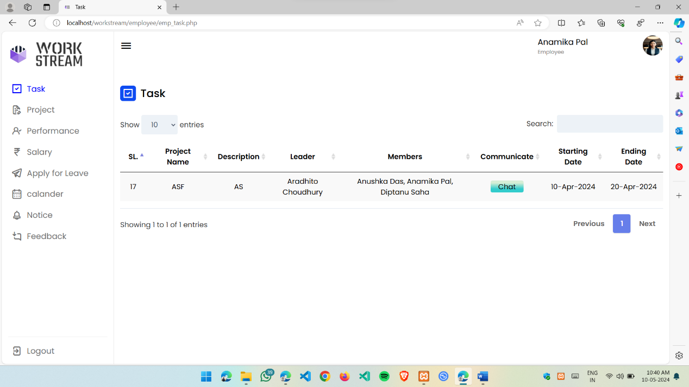

**Fig: 5.32. Employee Task Section**

* **Task Section:** In this section employee can see the task given by the manager to him or in a team in which he is also included.

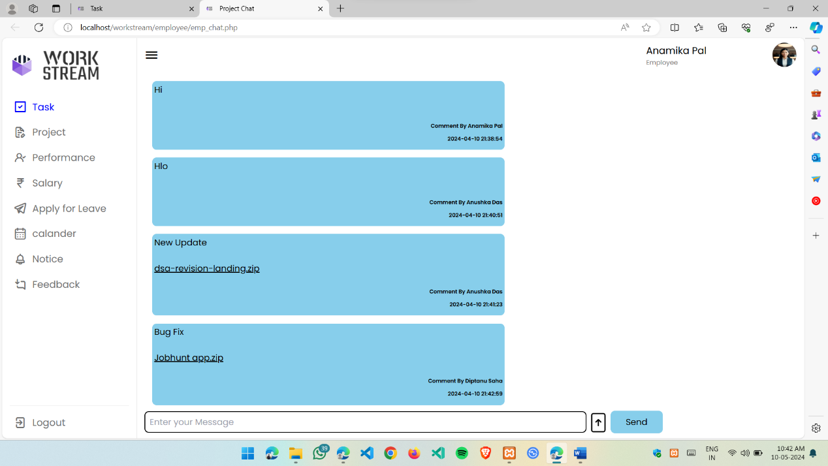

**Fig: 5.33. Employee Chat Section**

* **Chat Section:** In this section the employees can chat or discuss among there group members regarding their project or related to project and they can also share the project files or any other file related to project.

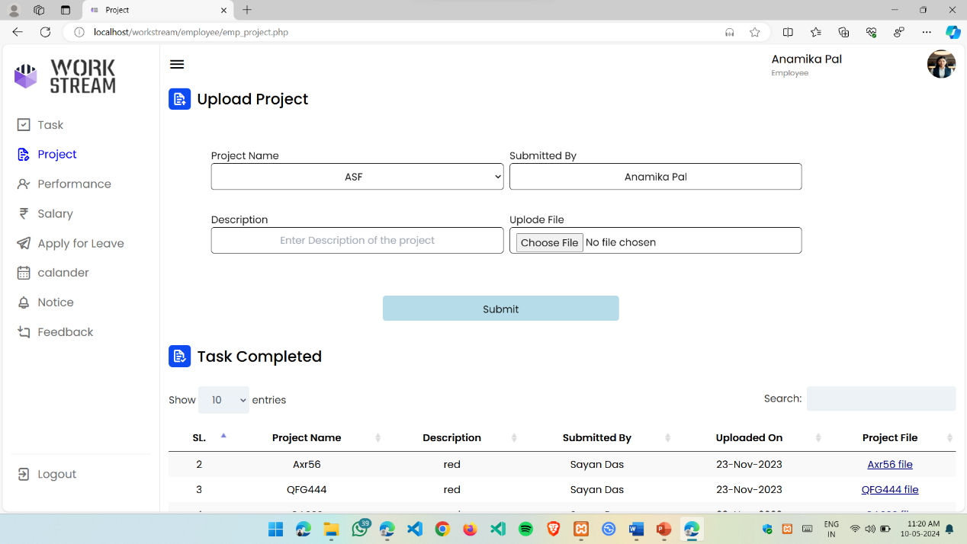

**Fig: 5.34. Project Upload**

* **Project Upload:**  In this section, the employee can upload the project files after the completion by him or someone in his team. And after uploading he or someone who is also in that project team can see the history and also download the project file.

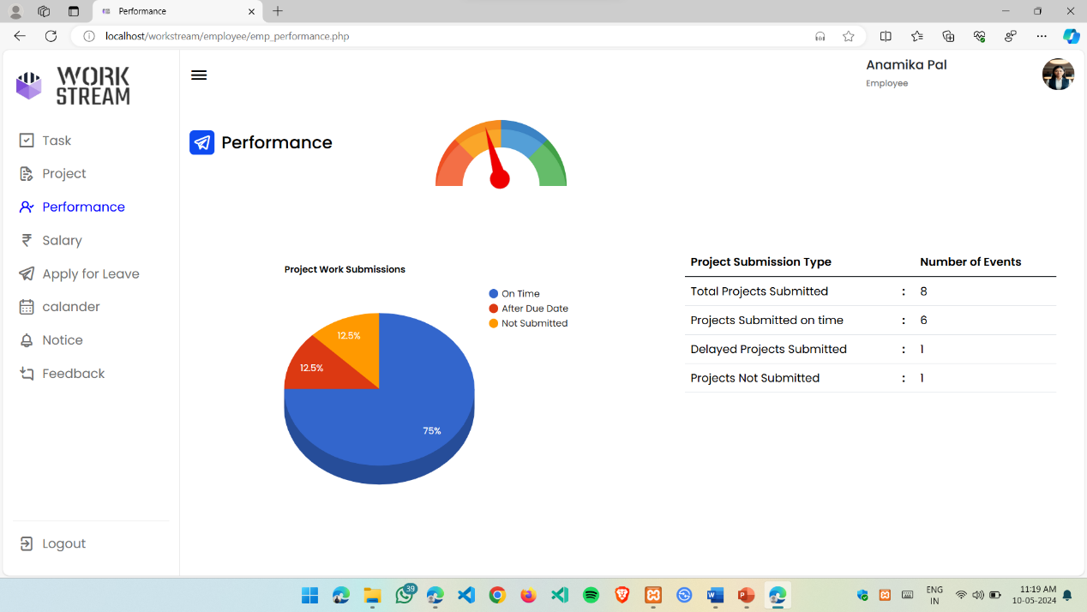

**Fig: 5.35. Performance**

* **Performance:**  In this section the employee can see his/her performance depending on their work.

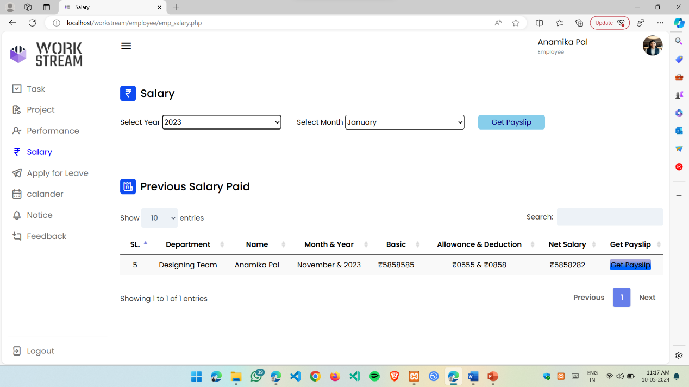

**Fig: 5.36. Salary**

* **Salary:** In this section the employee can download the salary pay slip of last three months from the previous salary paid and from the upper part, by giving the year and month he can download the previous ones.

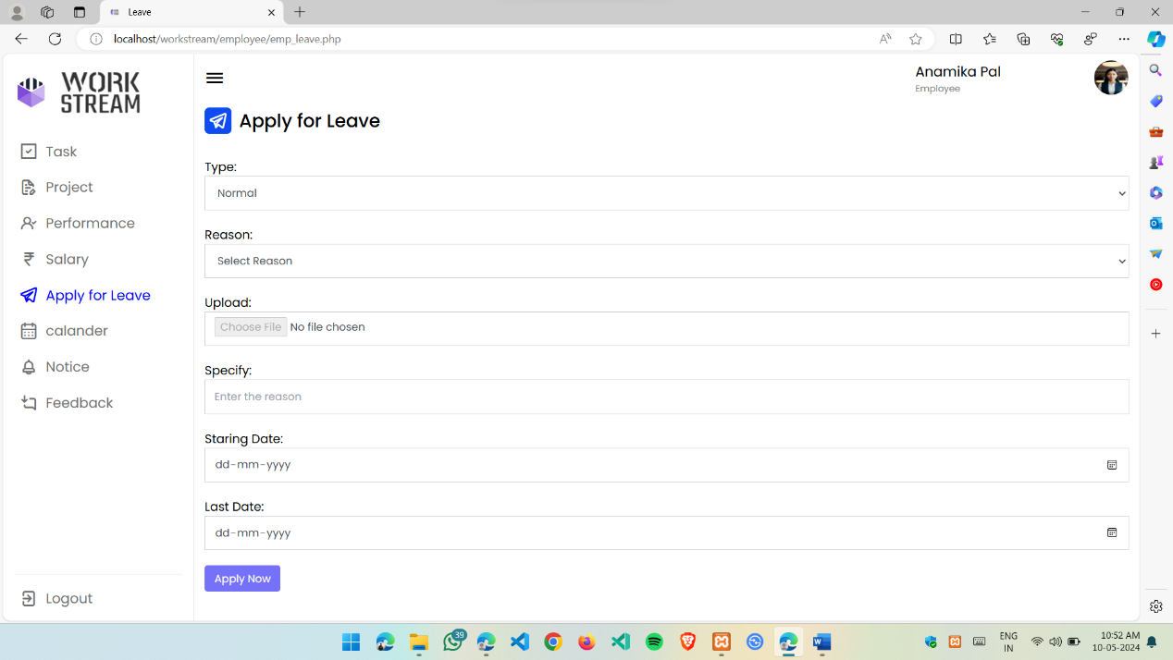

**Fig: 5.37. Apply for Leave**

* **Apply for leave:**  In this section employee can apply for leave to the admin, here he can give the reason for leave and the starting and the ending date. He can also see the previous leave requests.

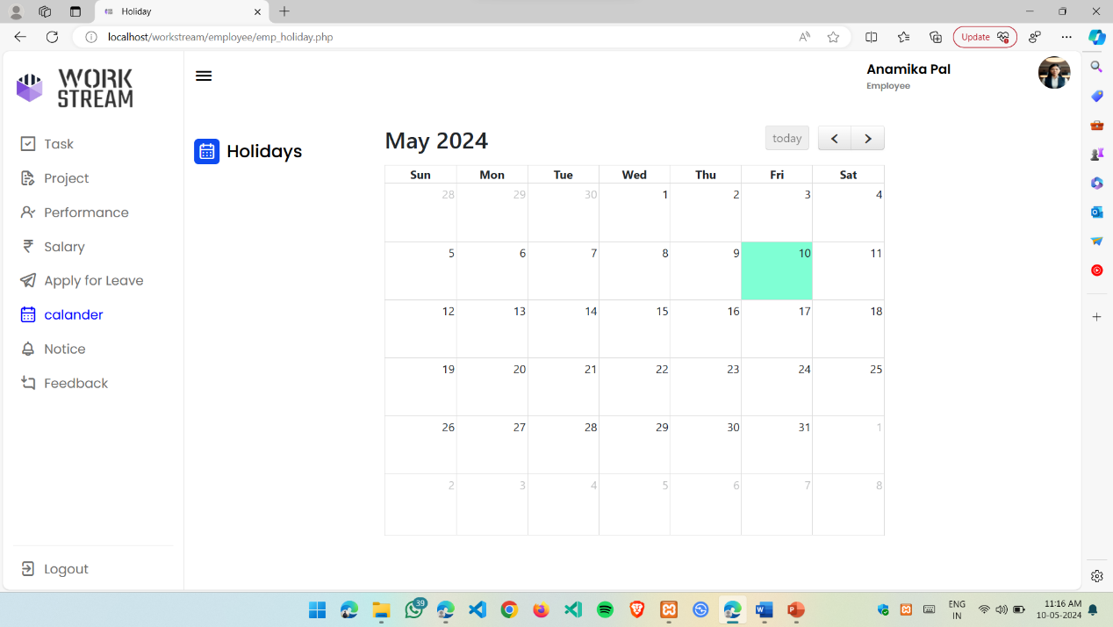

**Fig: 5.38. Calendar**

* **Calendar:** In this section employee can see all the holidays, meetings and upcoming events set by the admin.

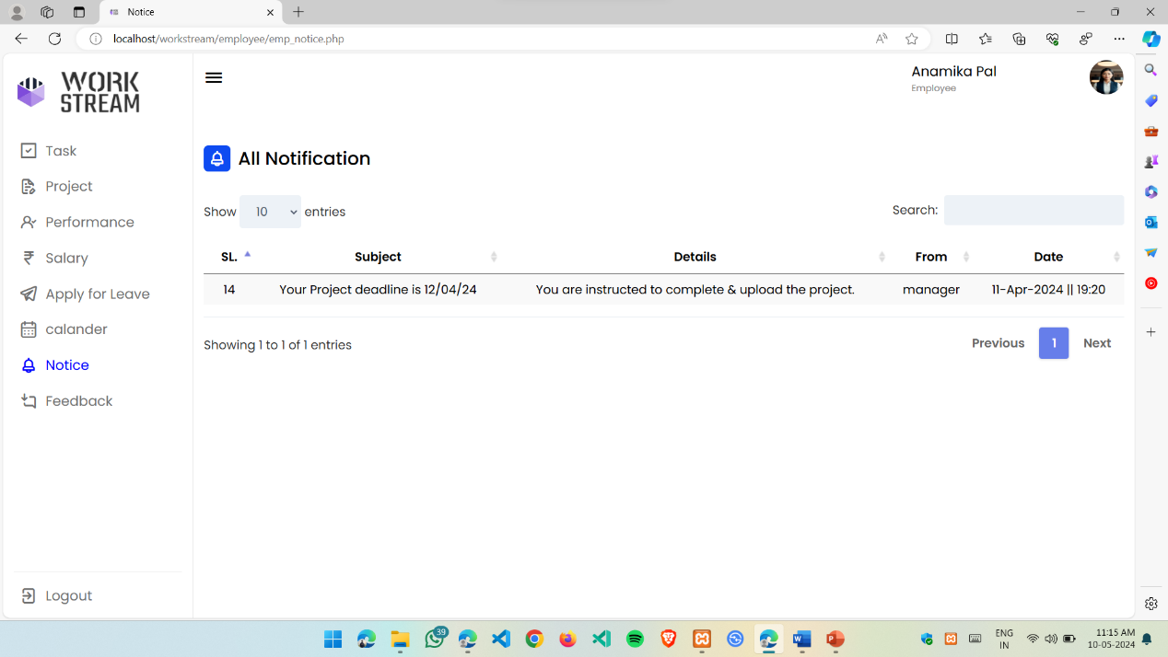

**Fig: 5.39. Notifications**

* **Notifications:**  In this section employee can see all the notifications given to him by the admin or the manager of his department.

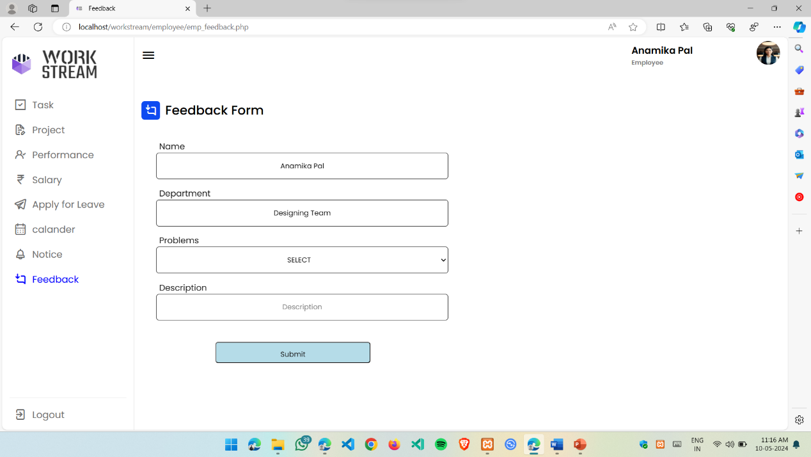

**Fig: 5.40. Feedback form**

* **Feedback form:** In this form employee can give feedbacks to the admin regards of anything such as any issue related to project or anything else.

**Chapter 6**

Implementation

**6.1. Introduction to Languages**

In the development of office management system, various programming languages are utilized to create a robust and interactive application. The key programming languages used in this system are PHP, MySQL, HTML, Tailwind CSS, AJAX, Apache server, and JavaScript for form validation.

**6.1.1. PHP:** PHP (Hypertext Preprocessor) is a server-side scripting language specifically designed for web development. It is used to handle dynamic content generation, server-side processing, and database interactions. PHP provides powerful features for handling form submissions, data retrieval and manipulation, and integrating with databases like MySQL.

**6.1.2. MySQL:** MySQL is a popular open-source relational database management system (RDBMS). It is used in conjunction with PHP to store and retrieve data efficiently. MySQL offers a comprehensive set of features for database management, such as creating tables, executing queries, and ensuring data integrity.

**6.1.3. HTML:** HTML (Hypertext Markup Language) is the standard markup language for creating the structure and content of web pages. It is responsible for defining the layout, text, images, and other elements of the user interface in the online doctor appointment system. HTML is used to structure the web pages and provide the necessary semantic meaning.

**6.1.4. Tailwind CSS:** It is a utility-first CSS framework that has surged in popularity, reshaping the paradigms of frontend design. Rather than contending with obscure class names or battling specificity wars, Tailwind empowers developers to build responsive, maintainable, and scalable user interfaces with ease

**6.1.5. JavaScript:** JavaScript (JS) is a client-side scripting language that enhances interactivity and user experience. In the context of the online doctor appointment system, JavaScript is used for form validation. It allows for client-side validation of user input before submitting the form to the server, ensuring data accuracy and reducing server-side processing and error handling.

**6.1.6 AJAX:** Asynchronous JavaScript and XML (Ajax) refer to a group of technologies that are used to develop web applications. By combining these technologies, web pages appear more responsive since small packets of data are exchanged with the server and web pages are not reloaded each time that a user makes an input change.

**6.2. IDE**

**6.2.1 VS Code:** Yes, Visual Studio Code (VS Code) is a popular IDE that can be used for developing the online doctor appointment system. VS Code is a lightweight and highly customizable IDE developed by Microsoft. It offers a wide range of features and extensions that make it well-suited for PHP web development. Here's how VS Code can be utilized in the development of the online doctor appointment system:

PHP Development: VS Code provides excellent support for PHP development. It offers features like syntax highlighting, code completion, and error checking, which help streamline the coding process. VS Code also supports debugging PHP applications, allowing developers to easily identify and resolve issues.

HTML and CSS Editing: The online doctor appointment system requires HTML and CSS for creating the user interface. VS Code provides robust support for HTML and CSS editing, including features like auto-completion, code formatting, and real-time preview capabilities. This helps developers write and manage HTML and CSS code effectively.

JavaScript Integration: JavaScript is used for form validation and enhancing interactivity in the online doctor appointment system. VS Code includes comprehensive JavaScript support, including features like IntelliSense, debugging, and code refactoring. This allows developers to write and debug JavaScript code seamlessly within the IDE.

Extension Ecosystem: VS Code has a vast ecosystem of extensions that can be leveraged to enhance productivity and streamline development workflows. There are numerous extensions available for PHP, MySQL, HTML, Tailwind CSS, and JavaScript, offering additional functionality and integrations with various tools and frameworks.

**6.3. Pseudocode**

**6.3.1 Login into the system**

Startup system

Enter email and password

On clicking the login button

Connect to database

Query database to know whether user credentials are correct

If not

Deny access and return login page with an error message

If correct

Check if credentials are for admin

If yes

Allow login

Set admin session

Redirect administrator to admin home page

If no

Allow login

Set user session

Redirect user to user home page

**6.3.2 Add new user**

Check if admin is logged in

If correct

Check if all fields entered are correct

If not

System message: please enter all fields

If correct

Registration of new user successful

**6.3.3 Apply for leave**

Check if employee is logged in

If correct

Check if all fields are entered

If not

System message: please enter fields

Check if file has been attached

If not

System message: please attach file

If correct

Leave request has been made

**Chapter 7**

Conclusion

An office management system plays a crucial role in enhancing the efficiency, organization, and overall productivity of an office environment. By integrating various functions and automating routine tasks, it streamlines workflows and empowers teams to focus on strategic initiatives. The adoption of an office management system brings about several benefits, including improved collaboration, better communication, and more effective resource utilization.

In conclusion, a well-implemented office management system serves as the backbone of a modern workplace, providing the tools and features necessary for seamless coordination and task management. It contributes to the creation of a more agile and responsive office environment, enabling teams to adapt to changing demands and meet organizational goals more effectively. As technology continues to evolve, office management systems will likely play an increasingly pivotal role in shaping the future of work by fostering collaboration, enhancing transparency, and driving overall operational excellence within the office setting.

**Chapter 8**

Future Scope

**8.1. Future Scope**

1. **Enhanced Collaboration and Communication:**

* Improved collaboration features, including real-time document editing, instant messaging, and video conferencing integration.
* Integration with project management tools for seamless coordination and task tracking.

1. **Mobile Accessibility:**

* Increased emphasis on mobile accessibility, allowing users to manage tasks, access information, and communicate while on the go.
* Development of mobile apps with intuitive interfaces for various platforms.

1. **Data Security and Privacy:**

* Advanced security features to protect sensitive data, including encryption, multi-factor authentication, and compliance with the latest data protection regulations.
* Regular updates and patches to address new security threats and vulnerabilities.

1. **Customization and Scalability:**

* More robust customization options, allowing organizations to tailor the system to their specific needs.
* Scalability to accommodate the growth of businesses and the addition of new features as technology evolves.

1. **Environmental Sustainability:**

* Integration of features that promote environmental sustainability, such as paperless workflows, energy-efficient settings, and tools for tracking and reducing the organization's carbon footprint.

1. **User-Friendly Interface:**

* Continued focus on creating user-friendly interfaces to enhance user adoption and minimize training requirements.
* Accessibility features to ensure inclusivity for users with different abilities.

**Chapter 9**

References

* **[www.clickup](http://www.clickup).com**
* **www.basecamp.com**
* **www.**[**smarttask**](mailto:SmartTask)**.us**
* **www.workstream.com**
* [**www.empnode.com**](http://www.empnode.com)
* **www.** **geeksforgeeks.org**
* **www.** **Wikipedia.org**
* **www.helpdesk.in**

1. **Enhanced Collaboration and Communication:**
   * Improved collaboration features, including real-time document editing, instant messaging, and video conferencing integration.
   * Integration with project management tools for seamless coordination and task tracking.
2. **Mobile Accessibility:**
   * Increased emphasis on mobile accessibility, allowing users to manage tasks, access information, and communicate while on the go.
   * Development of mobile apps with intuitive interfaces for various platforms.
3. **Data Security and Privacy:**
   * Advanced security features to protect sensitive data, including encryption, multi-factor authentication, and compliance with the latest data protection regulations.
   * Regular updates and patches to address new security threats and vulnerabilities.
4. **Customization and Scalability:**
   * More robust customization options, allowing organizations to tailor the system to their specific needs.
   * Scalability to accommodate the growth of businesses and the addition of new features as technology evolves.

[1] Arthur Hylton III and Suresh Sankaran arayanan

“Application of Intelligent Agents in Hospital Appointment

Scheduling System”, International Journal of Computer Theory and

Engineering, Vol. 4, August 2012, pp. 625-630.